Packet Tracer – Troubleshooting Enterprise Networks 1

1. Topology

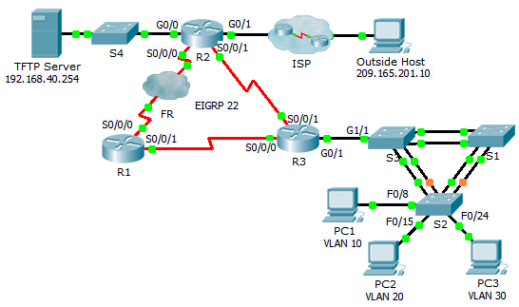

1. Addressing Table

|  |  |  |  |  |
| --- | --- | --- | --- | --- |
| Device | Interface | IP Address | Subnet Mask | Default Gateway |
| R1 | S0/0/0 | 10.1.1.1 | 255.255.255.252 | N/A |
| S0/0/1 | 10.3.3.1 | 255.255.255.252 | N/A |
| R2 | G0/0 | 192.168.40.1 | 255.255.255.0 | N/A |
| G0/1 | DHCP assigned | DHCP assigned | N/A |
| S0/0/0 | 10.1.1.2 | 255.255.255.252 | N/A |
| S0/0/1 | 10.2.2.1 | 255.255.255.252 | N/A |
| R3 | G0/0.10 | 192.168.10.1 | 255.255.255.0 | N/A |
| G0/0.20 | 192.168.20.1 | 255.255.255.0 | N/A |
| G0/0.30 | 192.168.30.1 | 255.255.255.0 | N/A |
| G0/0.88 | 192.168.88.1 | 255.255.255.0 | N/A |
| S0/0/0 | 10.3.3.2 | 255.255.255.252 | N/A |
| S0/0/1 | 10.2.2.2 | 255.255.255.252 | N/A |
| S1 | VLAN 88 | 192.168.88.2 | 255.255.255.0 | 192.168.88.1 |
| S2 | VLAN 88 | 192.168.88.3 | 255.255.255.0 | 192.168.88.1 |
| S3 | VLAN 88 | 192.168.88.4 | 255.255.255.0 | 192.168.88.1 |
| PC1 | NIC | DHCP assigned | DHCP assigned | DHCP assigned |
| PC2 | NIC | DHCP assigned | DHCP assigned | DHCP assigned |
| PC3 | NIC | DHCP assigned | DHCP assigned | DHCP assigned |
| TFTP Server | NIC | 192.168.40.254 | 255.255.255.0 | 192.168.40.1 |

1. Background

This activity uses a variety of technologies you have encountered during your CCNA studies, including VLANs, STP, routing, inter-VLAN routing, DHCP, NAT, PPP, and Frame Relay. Your task is to review the requirements, isolate and resolve any issues, and then document the steps you took to verify the requirements.

1. Requirements

**VLANs and Access**

* S2 is the spanning-tree root for VLAN 1, 10, and 20. S3 is the spanning-tree root for VLAN 30 and 88.
* The trunk links connecting the switches are in native VLAN 99.
* R3 is responsible for inter-VLAN routing and serves as the DHCP server for VLANs 10, 20, and 30.

**Routing**

* Each router is configured with EIGRP and uses AS 22.
* R2 is configured with a default route pointing to the ISP and redistributes the default route.
* NAT is configured on R2 and no untranslated addresses are permitted to cross the Internet.

**WAN Technologies**

* The serial link between R1 and R2 uses Frame Relay.
* The serial link between R2 and R3 uses HDLC encapsulation.
* The serial link between R1 and R3 uses PPP with CHAP.

**Connectivity**

* Devices should be configured according to the Addressing Table.
* Every device should be able to ping every other device.

1. Troubleshooting Documentation

|  |  |  |
| --- | --- | --- |
| Device | Problem | Solution |
|  |  |  |
|  |  |  |
|  |  |  |
|  |  |  |
|  |  |  |
|  |  |  |
|  |  |  |
|  |  |  |
|  |  |  |
|  |  |  |

1. Verification Documentation

Capture output from verification commands and provide documentation proving that each of the requirements has been satisfied.

1. Suggested Scoring Rubric

Packet Tracer scores 60 points. The troubleshooting documentation and instructor verification is worth 40 points.